ASTRO 310 FINAL REVIEW QUESTIONS

1. Recalling the Astro 310 satellite design project, identify each of the elements below as either a requirement or constraint:
30 meter resolution ______________
200 km swath width ______________
$241M budget ______________
2 yr mission life ______________
3º pointing accuracy ______________
42 month IOC ______________
Using the happy snap optical space camera with detector radius of .01m, focal length of .05 m, and aperture of .05 m, visible wavelengths of .6 to .8 µm and the requirements/ constraints above, what are your minimum and your maximum altitudes?

2. Given the atmospheric window chart below, could a subject at 145 K be sensed from space? Why or why not?

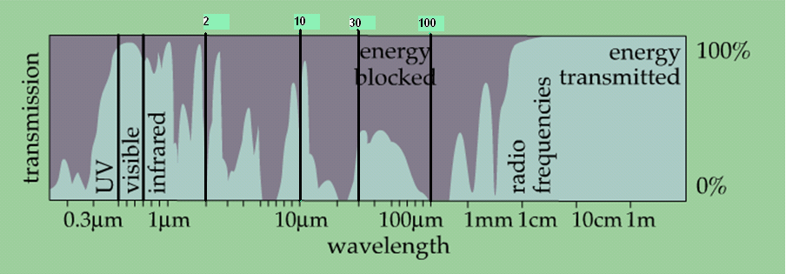

3. A spacecraft in a 300 km circular orbit has a pointing stability requirement of 100 m. What is the minimum pointing accuracy (in degrees) the bus ADACS must provide?

4. The vertical accelerometer of a launch vehicle is reading 34.29 m/s² right at liftoff from Cape Kennedy. What is the inertial acceleration of the launch vehicle in the vertical direction?

5. A satellite ADCS using a gravity gradient boom is an example of what type of control system (open or closed loop) and has what major disadvantage?

6. If a spacecraft sensor has a 4m aperture, what is the maximum mission altitude for a remote sensing payload to achieve .2 m resolution over the wavelength range .4μm < λ < 1μm ?

7. Which of the following statements accurately describes the design process?
A. It requires attention to detail to make sure every step is covered in a linear checklist. Once each step is "checked off", the design process is complete.
B. The design process is iterative and requires repeating previous steps. For example, as one subsystem changes, it affects others, which may require redesigning many subsystems.
C. The design process begins with the mission statement; then subsystems are designed. Finally, the system requirements are determined. This process is repeated until the design is finalized.
D. The design process varies considerably, depending on what you are building. For example, designing a satellite uses a completely different design process than building a deck on a house.

8. Identify the primary components of an Inertial Navigation System (INS) in the following diagram:
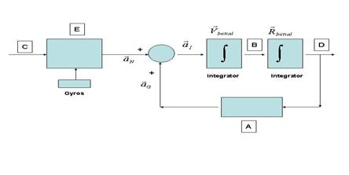
Accelerometer
Non-gravitational forces
Gravity Computer

- Given R = -8000I km, V = 7.0587K km/s (constant magnitude) What are Ω, i, & e?

- If M_{f} = 525 rads, what can I say about υ_{f}?

- Name a mission orbit that makes use of the J2 perturbation.

- What are the 5 elements of the space mission architecture?

- For a spacecraft in a circular orbit at 500km alt, what is the Earth’s angular radius?

- What are the 4 basic assumptions of the Hohmann transfer?

- What 3 major effects does the free fall environment have on humans?

- Name 3 of the six space hazards.

- Name 3 of the 5 unique advantages of the space environment.

- If an upper stage rocket has an I_{sp} of 200s, a ΔV capability of 2000m/s and a final mass of 1700kg, what is m_{i}?

- What two quantities are conserved in a restricted 2-body orbit?

- If TE = .59hrs, P_{e} = 62W, and DOD is 35%, what is the required battery capacity for this spacecraft?

- Given problem 17, if TS = 1.01hrs and P_{s}=100W, what must P_{eol} for the spacecraft’s sun tracking solar arrays be?

- Given the following COEs, draw the ground track. Identify i, ∆N, and where perigee is: a = 16763.39, e = .5, i = 50, ω = 90°, and Ω = 0°.

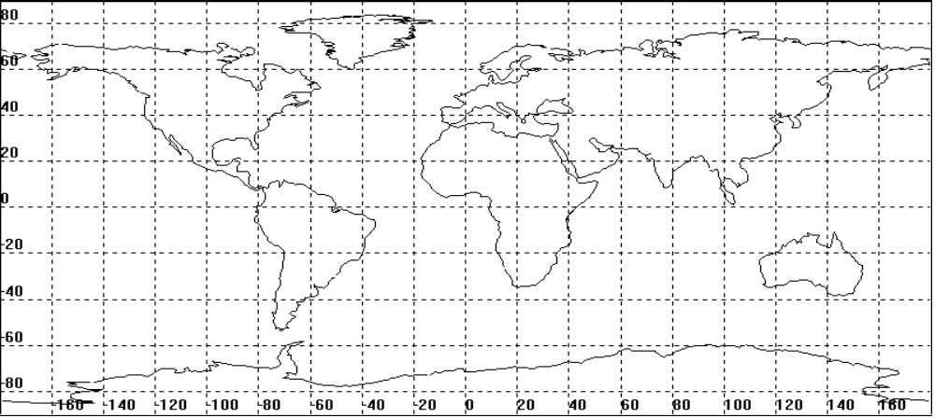

- Study how a simple Hohmann transfer solves most of the calculations for time and wait time for a mission from earth to mars.

- If V_{re-entry} increases, what happens to the alt where max deceleration occurs?

- If φ_{f} = 1.889 rads, φ_{i} = 5.707 rads, ω_{tgt} = 8.27E-7, and ω_{int} = 1.991E-7, what is the wait time for this rendezvous problem in days?

- If I find myself in the same orbit as my target, but trailing it. What should I do to rendezvous with it?

- Given υ_{o} = oº, υ_{f} = 270º, a = 1.496E8 km, and e = .017, what is the TOF? Assume you are in an orbit around the Sun. (μ_{Sun} = 1.327E11 km³/s²)

- What is the most efficient way to go from a larger orbit to a smaller orbit in a different plane?

- What is the name of the equation we use to describe satellite motion? What are the two forms of this equation? What are the assumptions associated with it?

